HADRIAN’S VILLA

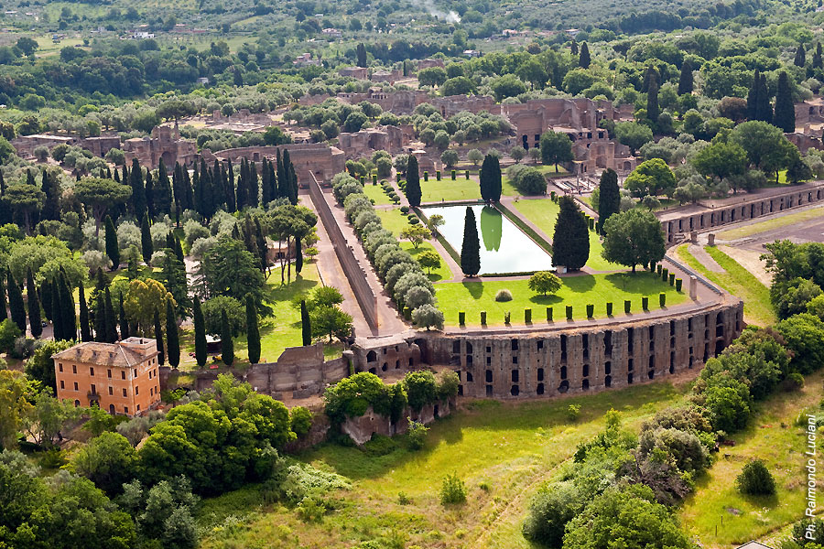Address: Largo Marguerite Yourcenar, 1-00019 Tivoli (RM)
- Tickets: Standard Ticket: 8.00; Reduced Ticket: 4.00; with events 11.00
- Tickets information: +39 0774382733
- Telephone: +39 0774 530203
- Fax: +39 0774 531979
Email: villaadriana@coopculture.it (mailto:villaadriana@coopculture.it)

Hadrian’s Villa in Tivoli bears witness to the grandeur of the Roman Empire. It is one of the best kept and most visited archaeological sites in Italy. This is why it has been listed as a UNESCO World Heritage Site since 1999.
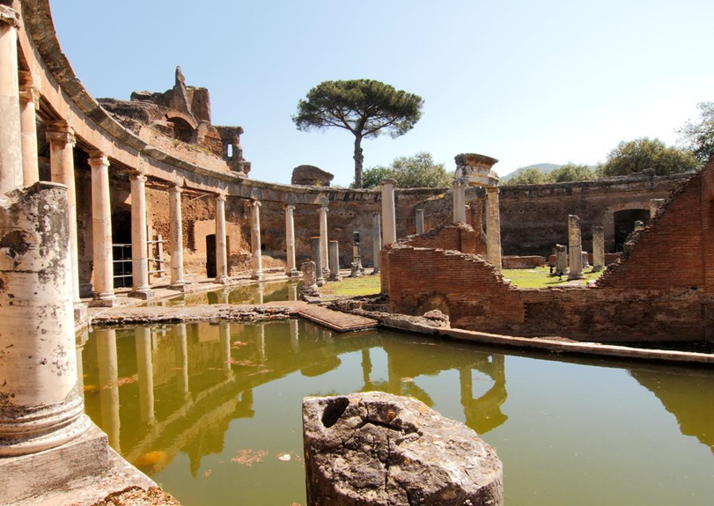
The villa was built by Roman Emperor Hadrian at the foot of the Tiburtine Hills between 118 and 138 AD. The vast Residential complex extend over an area of about 120 hectares (about 300 acres) and looked very much like an ancient Roman city. The site included buildings, baths, temples, barracks, theatres, gardens, fountains, and nymphaeums. The villa itself was designed on two levels: the upper floor, quiet and welcoming, was reserved for the Emperors official use, while the lower floor was noisy and bustled with the work of slaves. Today, of the ancient pomp, It is possible to see only 40 hectares, which fortunately still attest to the magnificence and significance of this complex. Some parts were explicitly commissioned by Hadrian to represent the empire’s many provinces that he had visited himself:
- THE VESTIBULE, which connected the Great and small Baths;
- THE CANOPUS, a long canal lined by columns of caryatids in homage to the ancient Egyptian city of the same name;
- THE MARITIME THEATRE, a portico which contained a round pool representing the sea;
- THE PECILE, a long covered portico once used for panoramic strolls;
- THE GREAT AND SMALL BATHS, places where endless days would be spent on wellness;
- THE GREEK THEATRE, a small court theatre reserved to only a few guests;
- THE GREEK LIBRARY AND LATIN LIBRARY, : repositories of knowledge.
In the 16th century, Cardinal Ippolito II d'Este had much of the remaining marble and statues in Hadrian's Villa removed to decorate his own Villa d'Este located nearby. Since that period excavations have sporadically turned up more fragments and sculptures, some of which have been kept in situ or housed on site in the display buildings.
