The fountains’ water comes from the Carolino aqueduct, which is 38 km long.
In the gardens of the Royal Palace of Caserta there are 5 fountains:

- THE FOUNTAIN OF THE THREE DOLPHINS
It was made by Gaetano Salomone between 1776 and 1779 and it represents a sea monster with the head of a dolphin and beside it there are two dolphins.
It is 27m long and 3m deep.

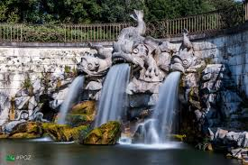

- THE FOUNTAIN OF EOLO
It represents the God of the winds Eolo and it is one of the unfinished works of the royal palace.

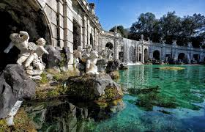

- THE FOUNTAIN OF CERERE
It represents Cerere, the Goddess of fertility, and it was made by Gaetano Salomone between 1783 and 1785.

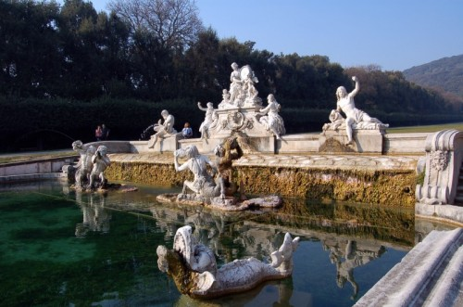

- THE FOUNTAIN OF VENERE AND ADONE
It represents Venere who is imploring Adone not go hunting because she wants to save him from his destiny.
It was made by Gaetano Salomone.

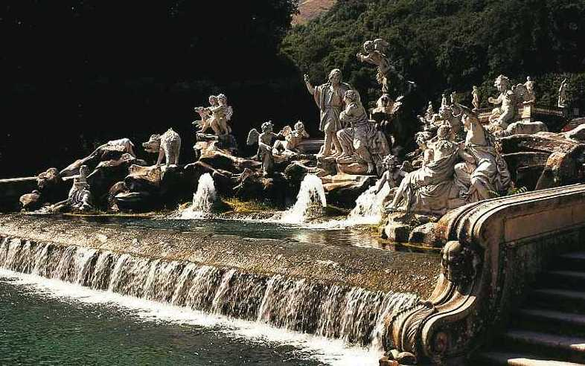

- THE FOUNTAIN OF DIANA AND ATTEONE
It is the last fountain in the park and it has a huge waterfall that is 82 m high.
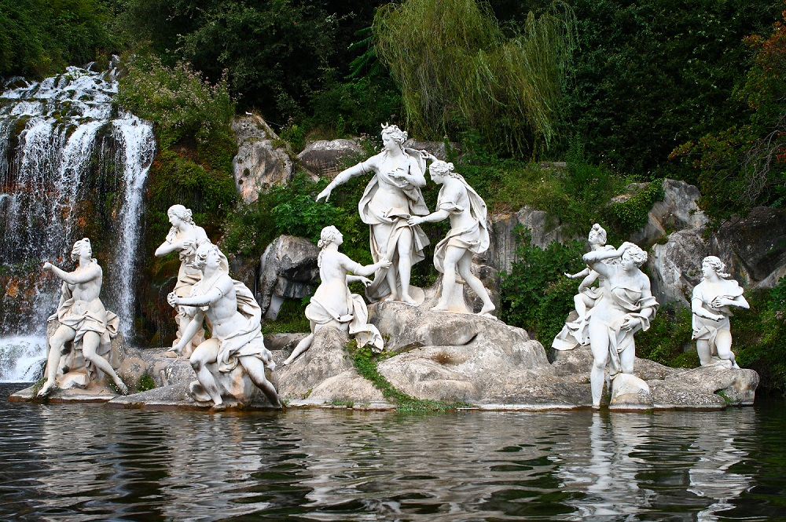

Luigi Vanvitelli started building the parks of the Royal Palace of Caserta in 1753 and he was inspired by the great European palaces of that age.
It covers 120 hectares and it is 3.3 km long. It’s a reduced version of the royal park that Luigi Vanvitelli had designed.

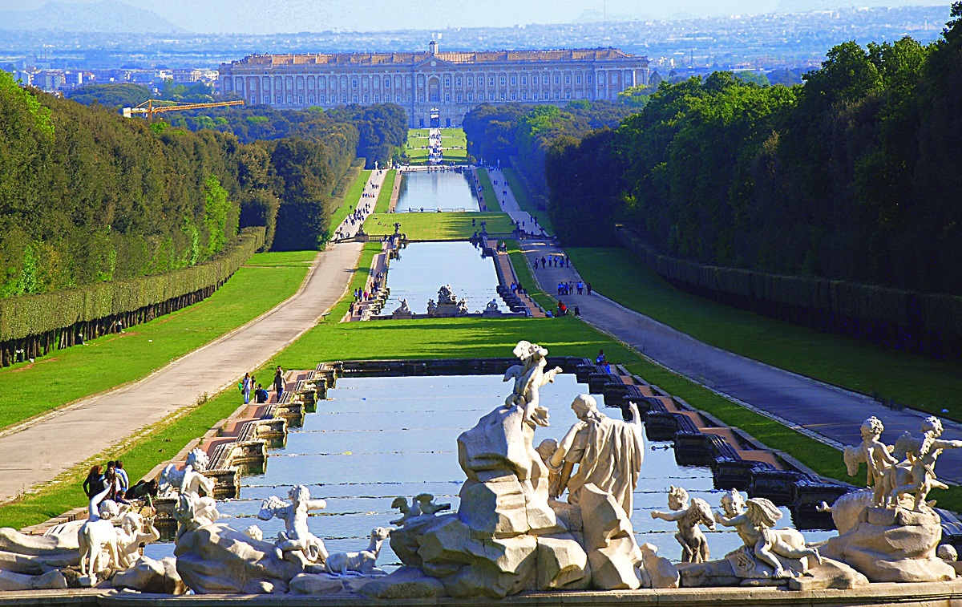

Our address:
Viale Douhet 2/a 81100 Caserta CE

Our timetable:
From Monday to Sunday from 8:30 to 19:30

Our Prices:
Adults = € 12
18-25 years old = € 6
Free entry under 18 years old

Realized by: Sara Biraschi, Giorgia D’Amico,
Sharon Lanzone, Alice Lafratta

