The Aqueduct Of Vanvitelli

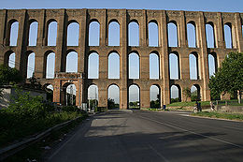

[**Acquedotto Carolino - Wikipedia**](https://it.wikipedia.org/wiki/Acquedotto_Carolino)

Why visit it?

# You should visit Aqueduct Caroline because it iso ne of the best cultural attraction in Campania region. You can also visit the Royal Palace of Caserta and its fantastic gardens and fountains. You should visit the beautiful town of Caserta.

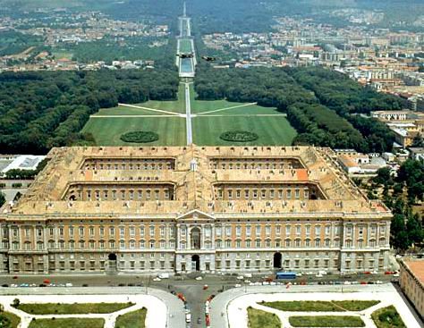

[La fastosa Reggia di Caserta - Stu](http://www.studiarapido.it/la-fastosa-reggia-di-caserta/)

Luca Socci Domenico Capuano Miro Rossin Lorenzo Grimaldi Carmine Starita 2^D

# Luca Socci Domenico Capuano Lorenzo Grimaldi Carmine Starita Miro Rossin 2^D

# The Aqueduct of Vanvitelli or Caroline is an aqueduct built to supply water the Royal Palace of Caserta and San Leucio complex.

History and location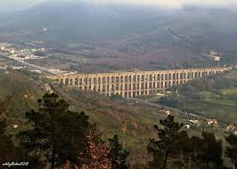

[**Acquedotto Carolino - Wikipedia**](https://it.wikipedia.org/wiki/Acquedotto_Carolino)

# This aqueduct is situated in Caserta (Italy). It was commissioned by Charles of Bourbon and designed by Luigi Vanvitelli. Its construction began in March 1753 and concluded with its opening on 7 May 1762.

Three bridges

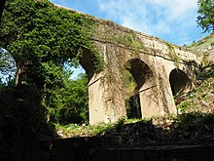vvv

# [File:Ponte Durazzano.jpg - Wikipedia](https://it.wikipedia.org/wiki/File:Ponte_Durazzano.jpg)

# Aqueduct is made of three bridges: “Ponte Nuovo”, “Ponte della Valle di Maddaloni” and “Ponte della Valle di Durazzano”. All built by Vanvitelli. The first of these was the longest bridge in Europe when it was built and is a UNESCO heritage site. The others were built to cross the rivers: Martorana and Isclero

# 